React js
https://www.tpointtech.com/react-code-splitting
https://www.geeksforgeeks.org/reactjs/react/
https://www.w3schools.com/REACT/default.asp
https://www.w3schools.com/REACT/react_es6.asp
React Tutorial (javascripttutorial.net)
https://www.javatpoint.com/reactjs-tutorial
https://www.geeksforgeeks.org/react-tutorial/
https://www.freecodecamp.org/news/react-for-beginners-handbook/
https://www.datarmatics.com/reactjs/react-js-refs/
https://www.frontendmag.com/categories/tutorials/
https://codegnan.com/react-js-course-syllabus/
https://www.scaler.com/topics/course/free-react-js-course/
Resource
code volution
code step by step
yoshita jain
thapa technical
Interview pro
https://youtu.be/Em2FgrQ1LuA

search by topics

Javatpont
https://www.javatpoint.com/reactjs-tutorial
https://www.tpointtech.com/reactjs-tutorial
ES6
React Tutorial
https://www.tpointtech.com/reactjs-tutorial
React is a JavaScript library for creating the Graphical User Interface (GUI) of web applications.
It is used specifically for creating mobile applications and single-page web applications.
The code structure in React is constructed in the form of components, which are categorized into functional components and class components.
The functionality of React employs the
Document Object Model (DOM),
Virtual DOM,
JSX (JavaScript XML),
and a number of Lifecycle methods like 'render,' 'shouldComponentUpdate,' 'componentDidMount,' and 'componentWillUnmount.'

Features of React
https://www.tpointtech.com/reactjs-tutorial
1) JSX
2) Virtual Document Object Model
3) Testability
4) SSR
5) One-Way Data Binding
6) Simplicity
7) Learning Curve

Why learn React?
https://www.tpointtech.com/reactjs-tutorial
Flexibility:
Great Developer Experience:
Strong Support from Facebook:
Vast Community Support:
Excellent Performance:
Easy Testing:

Advantages of React
https://www.tpointtech.com/reactjs-tutorial
Composable:
Declarative:
SEO-Friendly:
Large Community: Easy to Learn
Easy Debugging:

React Version
https://react.dev/versions
Latest version: 19.2

React Environment Setup
https://www.tpointtech.com/react-installation
- Webpack
- Babel
Let’s break down Webpack and Babel in React.js — these two tools work behind the scenes to make your React app run smoothly in browsers. 🚀
🧩 1. Webpack
👉 What it is:
Webpack is a module bundler.
It takes all your project files (JavaScript, CSS, images, etc.) and bundles them into a few optimized files that browsers can understand.

⚙️ What Webpack does:
- Combines (bundles) your JS, CSS, and other assets into a single file (like bundle.js).
- Resolves dependencies — for example, when you import components or modules.
- Optimizes your code — minification, tree-shaking (removing unused code), etc.
- Runs a development server (via webpack-dev-server) for hot reloading.
🧠 Example:
// webpack.config.js
module.exports = {
entry: "./src/index.js", // starting point
output: {
path: __dirname + "/dist",
filename: "bundle.js"
},
module: {
rules: [
{
test: /\.js$/, // for JS/JSX files
exclude: /node_modules/,
use: "babel-loader" // use Babel for transpiling
}
]
},
devServer: {
static: "./dist",
},
};

🧬 2. Babel

👉 What it is:
Babel is a JavaScript compiler (transpiler).
It converts modern JavaScript (ES6/ES7, JSX) into older JavaScript (ES5) that all browsers can understand.
⚙️ What Babel does in React:
- Converts JSX → plain JavaScript.
- <h1>Hello React</h1>
- // becomes
- React.createElement('h1', null, 'Hello React');
- Converts modern ES6+ code into compatible code:
- const greet = () => console.log("Hi");
- // becomes
- var greet = function() { console.log("Hi"); }

🧠 Example:
// .babelrc (or babel.config.json)
{
"presets": ["@babel/preset-env", "@babel/preset-react"]
}

🔗 How They Work Together
- You write React JSX + ES6 code.
- Webpack finds your JS files and sends them through Babel (via babel-loader).
- Babel transpiles JSX and modern JS → browser-compatible JS.
- Webpack bundles everything → bundle.js (served to browser).
React Code → Babel (transpile) → Webpack (bundle) → Browser

⚡ In short:
Tool | Purpose | Example
Babel | Converts JSX and modern JS into browser-compatible JS | JSX → JS
Webpack | Bundles and optimizes all files | JS + CSS + Images → bundle.js

In React application, there are several files and folders in the root directory. Some of them are as follows:
https://www.tpointtech.com/react-create-react-app

- node_modules: It contains the React library and any other third party libraries needed.
- public: It holds the public assets of the application.
It contains the index.html where React will mount the application by default on the <div id="root"></div> element.
- src: It contains the App.css, App.js, App.test.js, index.css, index.js, and serviceWorker.js files. Here, the App.js file always responsible for displaying the output screen in React.
- package-lock.json:
It is generated automatically for any operations where npm package modifies either the node_modules tree or package.json.
It cannot be published. It will be ignored if it finds any other place rather than the top-level package.
- package.json: It holds various metadata required for the project. It gives information to npm, which allows to identify the project as well as handle the project?s dependencies.
- README.md: It provides the documentation to read about React topics.

React Features
https://www.tpointtech.com/react-features
1. Component-Based Architecture
2. Virtual DOM
3. Declarative Syntax
4. JSX (JavaScript XML)
5. Unidirectional Data Flow
6. Reusable Components
7. React Ecosystem
8. Community and Resources
9. Server-Side Rendering (SSR)
10. Mobile Development
11. Community and Ecosystem
12. Developer Tools
13. Immutability
14. Context API
15. Hooks:
16. Accessibility

Pros and Cons of React
https://www.tpointtech.com/pros-and-cons-of-react
Advantage of ReactJS
2. Creating Dynamic Web Applications Becomes Easier
3. Reusable Components
4. Performance Enhancement
5. The Support of Handy Tools
6. Known to be SEO Friendly
7. The Benefit of Having JavaScript Library
8. Scope for Testing the Codes

Disadvantage of ReactJS
1. The high pace of development
2. Poor Documentation
3. View Part
4. JSX as a barrier

Single Page Application
🧩 What is a Single Page Application (SPA)?
A Single Page Application is a web app that loads only one HTML page (index.html) and dynamically updates the content as the user interacts with the app — without reloading the whole page.
React is perfect for building SPAs because of its component-based structure and virtual DOM.

⚙️ How It Works
- When you visit a React app (like myapp.com), the server sends one HTML file (index.html).
- React takes over the page using JavaScript (React DOM).
- When you click links or buttons (like navigating to /about or /contact), React:
  - Does not reload the page.
  - Uses the React Router to change the URL and render components dynamically.
- This makes navigation fast and provides a smooth user experience.

⚡ Advantages of SPA
✅ Fast navigation (no full reloads)
✅ Better user experience
✅ Reusable components
✅ Easy to manage front-end with frameworks like React

⚠️ Disadvantages of SPA
❌ Slower first load (needs to load JS bundle)
❌ SEO challenges (though React can use SSR or Next.js for that)
❌ Browser history handling can be tricky (solved by React Router)

React Interview Questions and Answers
https://www.tpointtech.com/react-interview-questions

Later

Virtual dom
The virtual DOM works fast as it only changes individual DOM elements instead of reloading complete DOM every time.
Functional Component
Npx create-react-app myapp
Npm start
Npm run build
Cannot find module 'ajv/dist/compile/codegen'
Require stack:
npm install --save-dev ajv@^7
React Features
- JSX
- Virtual DOM
- Unidirectional data
- Components
- One-way Data Binding
- Simplicity
- Performance
React Features - Tpoint Tech

Virtual DOM
A virtual DOM object is a representation of the original DOM object. It works like a one-way data binding.
Whenever any modifications happen in the web application, the entire UI is re-rendered in virtual DOM representation.
Then it checks the difference between the previous DOM representation and new DOM. Once it has done, the real DOM will update only the things that have actually changed. This makes the application faster, and there is no wastage of memory.
- Functional Components
- Class Components

Why functional component over class component
Components in React are the building blocks of an application.
Basically, a React component returns a JSX element that is rendered in the UI. Moreover, a component can have other aspects such as state, props, and lifecycle methods.
React has two types of components:
- Class components
- Functional components
As the name suggests,
a class component is a JavaScript class extended to a React Component. It has a mandatory render() method which returns a JSX element. Earlier, React was mostly class-based because “state” was only supported in class components.
But in React 16.8, React hooks were introduced and these hooks changed everything in React development.
With React hooks, “state” could be declared in functional components, thus, transforming them into stateful components from stateless components.
Today, most professional React developers prefer and recommend functional components over class components. Thus making functional components, present as well as the future of React development. In this article, we will discuss what are the functional components in React.
state : stateful components
A functional component is a plain JavaScript function that returns a JSX element.
React Functional Components: State, Props, and Lifecycle Methods (ordinarycoders.com)
The state of a component in React is a plain JavaScript object that controls the behavior of a component. The change in a state triggers component re-renders.
props(properties)
React Functional Components: State, Props, and Lifecycle Methods (ordinarycoders.com)
In child component we can use props like this
1. Child Component
pass parameter as {props}
{props.name} //use
2. Child component
pass parameter as {name}
{name} //use
how we pass string, number and Boolean
const App = () => {
return (
<div>
<MyComponent name="Geeks"
age={25} isAdmin={true} />
</div>
);
};
lifecycle
React Functional Components: State, Props, and Lifecycle Methods
understand this lifecycle method from the code step by step

Example – componentwillunmount
import React, { useState, useEffect } from "react";

export default function App() {
const [flag, setFlag] = useState(false);

return (
<>
<button onClick={() => setFlag(!flag)}>Toggle child</button>
{flag ? <Child /> : null}
</>
);
}

const Child = () => {
useEffect(() => {
return () => {
console.log("Component unmounted");
};
}, []);

return <h2>Child component</h2>;
};

👉 If you remove <React.StrictMode>, the unmount log will appear only when you actually toggle it off.

React Props Validation
Props Validation
PropTypes
How to use PropTypes in a Functional Component in React? - GeeksforGeeks
import PropTypes from 'prop-types';
MyComponent.propTypes = {
name: PropTypes.string.isRequired,
age: PropTypes.number.isRequired,
isAdmin: PropTypes.bool
};

MyComponent is a child Component
Different between state and props
state – mutabilitility
Props - immutable

React Forms
There are mainly two types of form input in React
- Uncontrolled component
- Controlled component
Different between controlled component and uncontrolled component
React Events
onClick event

React Conditional Rendering
- if
- ternary operator
- logical && operator
- switch case operator
- Conditional Rendering with enums

If
const isLoggedIn = props.isLoggedIn;
if (isLoggedIn) {
return <UserLogin />;
}
return true if the condition is true

logical && operator
{
condition &&
// whatever written after && will be a part of output.
}
If you run the below code, you will not see the alert message because the condition is not matching.
('javatpoint' == 'JavaTpoint') && alert('This alert will never be shown!')

Ternary operator
condition ? true : false

Switch case operator
function NotificationMsg({ text}) {
switch(text) {
case 'Hi All':
return <Message: text={text} />;
case 'Hello JavaTpoint':
return <Message text={text} />;
default:
return null;
}
}

Conditional Rendering with enums
not able to understand properly
React Lists
React Keys
const stringLists = [ 'Peter', 'Sachin', 'Kevin', 'Dhoni', 'Alisa' ];
const updatedLists = stringLists.map((strList, index)=>{
<li key={index}> {strList} </li>;
})
{props.data.map((show) =>
<li key={show.id}>
{show.title}
</li>
)}
React Refs
it is used when we want to change the value of a child component, without making the use of props.
When we need DOM measurements such as managing focus, text selection, or media playback.

notes .
code step by step react js
Branches · anil-sidhu/react-17 · GitHub
virtual dom update only required list

https://www.w3schools.com/REACT/default.asp
npx create-react-app myapp
Install React 18
npm i react@latest react-dom@latest
- Classes
- Arrow Functions
- Variables (let, const, var)
- Array Methods like .map()
- Destructuring
- Modules
- Ternary Operator
- Spread Operator

Javascript variable scope
virtual dom
javascript – es5 concepts –
babel
jsx
React – tech info it
https://youtu.be/4u6GJS6lJOU?si=77E-bRFYtKRJIHuB

Thapa technicals
https://youtu.be/4z9bvgTlxKw?list=PLwGdqUZWnOp1Rab71vx2zMF6qpwGDB2Z1

GitHub - thapatechnical/react-19-series-thapa-technical: react-thapa

https://www.thapatechnical.com/2024/06/react-series-json-file-for-netflix.html
https://github.com/thapatechnical/react-19-series-thapa-technical/tree/master

node js installation lts version

vite
npm I -g bun
bun create vite
bun run dev
export default app
export app

to install react 19 version in the abode existing one
bun install react@rc
package.json
npx create-react-app myapp

install react js application using npm
npm create vite@latest
npm run dev

package.json
all the dependencies here

JSX (JavaScript XML)
Jsx gives us power to write html and javascript together

Images in react js
Image ko hamesha public folder ke undar rkhna hai
Or hum direct access kr skte hai
Public(folder)/quote.jpg
<img src = “quote.jpg” alt = ‘quote.jpg’>

Component
Functional Component
Class Components

React Fragments
In react JS , a components can not return multiple elemetns without a wrapper div
To fix this react 16 introduced fragments , which allow components to return multiple elements without adding extra nodes to the dom.
Import {fragment} from ‘react’;
return <fragement> </fragement>
<> </>

Dynamic Values in JSX: Injecting JavaScript into HTML
You can add any variables of your components in jsx using {} syntax
function MyComponent(){
const value = ‘Hey’;
return <p>{value}</p>
}

JSX allow you to write JavaScript expression inside curly braces
includes operations , function calls, and other JavaScript expression.
produce a value.
Declarative
Imperative

Dynamic values using variables
Dynamic values using expressions – this includes operations, function call, and other javascript expressions.

React Conditional rendering in JSX
Conditional in JSX
If, ternary, logical && operater

If - if true then only executes
Ternary Operator {condition : true ? false}

Example
if(4>2) return “watch now”;

if (isGoal) {
return <MadeGoal/>;
}

If
Ternary
Logical &&
Switch

Our First React Interview Question & Answer
React dose not render false, null , undefined or NaN in the DOM.
these values, when used in JSX , will result in nothing being displayed
however 0 and empty strings are exceptions.
0 is rendered in the DOM because it is considered a valid react Node.
this means that if 0 is the result expression , it will appear in UI.
Empty Strings “ ”
are also considered valid expression and are rendered as well.
React Import and Export Explained
Default export and import
Named export and import
Mixed Export and Import

Default export and import
Default export : a file can have only one default export
Default import : while importing a default export , you can name the import whatever you like
Example
const Parent = () => {
console.log(‘parents’);
}
export default Parent;
import Parent from ‘./Parent ---file name’
const Child = () => {
console.log(‘child’);
}
export default Child;
Named export and import
Named export : a file can have multiple named exports
each named exports must be explicitly exported
named import : when importing named exports,
the import names must match the export names exactly.
named imports must be enclosed in curly braces
Example
export const Parent = () => {
console.log(‘parents’);
}
import {Parent, Parent1, Parent2} from ‘./Parent ---file name’ //here we can import many
export const Child = () => {
console.log(‘child’);
}

Combine export and import
ek hi file me multiple named export kr skte hai, but default wala sirf ek hi rhega
const Parent = () => {
console.log(‘parents’);
}
export default Parent;

export const Child1 = () => {
console.log(‘parents’);
}

export const Child2 = () => {
console.log(‘parents’);
}

Importing
Import Parent, {Child1, Child2} from “./parent”
or
Import {Child1, Child2} from “./parent”
Import Parent, from “./parent”

Looping in JSX: Netflix Series Card Creation
Map method Key
Src/api/seriseData.json
Array of an objects
[{},{},{}]
[{

"name" : "Monika1",
"age" : "271",
"address" : "Pune1"
},
{

"name" : "Monika2",
"age" : "272",
"address" : "Pune2"
}]

{Api.map((data) => (
<ul>
<li>{data.name}</li>
<li>{data.age}</li>
<li>{data.address}</li>
</ul>
))}
Or
{Api.map((data) => {
return (
<ul>
<li>{data.name}</li>
<li>{data.age}</li>
<li>{data.address}</li>
</ul>
);
})}
Props in React JS
Pass data from parent component to child component.
react props (properties) facilitate data transfer from parent to child component.
data flow unidirectionally ensuring a clear direction of information in react application.
props are immutable , meaning child components can not modify the data received from parents .
child components access props through their function parameter.
you can also pass JSX as props to another component.
React Functional Components: State, Props, and Lifecycle Methods (ordinarycoders.com)
Version One
function MyComponent(props) {
return (
<div>
<h1>{props.prop1}</h1>
<p>{props.prop2}</p>
</div>
);
}

(props)
// Destructuring
const { active, activeStatus } = props;
{active}
{activeStatus}

Version 2
function MyComponent({prop1, prop2}) {
return (
<div>
<h1>{prop1}</h1>
<p>{prop2}</p>
</div>
);
}

// Without destructuring
function MyComponent(props) {
return <h1>Hello, {props.name}</h1>;
}

// With destructuring
function MyComponent({ name }) {
return <h1>Hello, {name}</h1>;
}
name = “monika” //we can pass string in quote
Age = {23} //we can pass number in curly braces
React Destructuring Props in JSX
https://www.geeksforgeeks.org/destructuring-of-props-in-reactjs/

How to Deal with Errors and Warnings
stackoverflow

Passing JSX as Props in React
<Child
Name = “bob”
Age = {25}
Greeting = {
<div>
<strong>hello bob, keep up the great work</strong>
<div/>
}
>
<p>hobbies, gaming, Cooking</p> //child component ke undar jsx pass kr diye to uske kaise hum .. //pass kar skte hai : {props.children}
<button> Contact</button>
</Child>

We can use jsx like this
{props}
{props.greeting}
{props.children}

Add CSS Styling in React: Class vs ClassName
- className = “common-heading”
import “./components/style.css”

Inline CSS Styling in React.js
style = {{border : “4px 6px”}}
style={{color: "red"}}>

<Button style = {{
padding : “1.2rem 2.4rem”,
border : “none”,
fontSize : “1.6 rem”
}}> watch now</button>

Performance Consideration
defining inline styles directly within the JSX can lead to performance issues because a new object is created on every render.
to avoid this, define styles outside of render method or as constants.
const btn_style = {
backgroundColor : ‘blue’,
color : ‘white’
}
<button style = {btn_style}>watch now</button>
Conditional Styling for Dynamic UIs in React.js
Using className
Using Inline Style

Css conditional styling in react js
You can use ternary operators to add conditional styling to your CSS.

Example
<h3>Rating :
<span className = {rating >= 8.5 ? “super-hit” : “average”}>
{rating}
</span>
</h3>

const btn-style = {
Background-color : `${rating >= 8.5 ? ‘#7ytfg0’ : “8i78nkjbjk”}`
}

CSS Modules in React: Scoped and Reusable Styles skip
Styled Components in React JS for Clean and Dynamic UI skip
Tailwind CSS in React v19: Installing and Using Tailwind CSS to Style Your React App skip
Event Handling in React: Synthetic Events, Naming Conventions of Events & Functions & More
Events handling
SyntheticBaseEvent

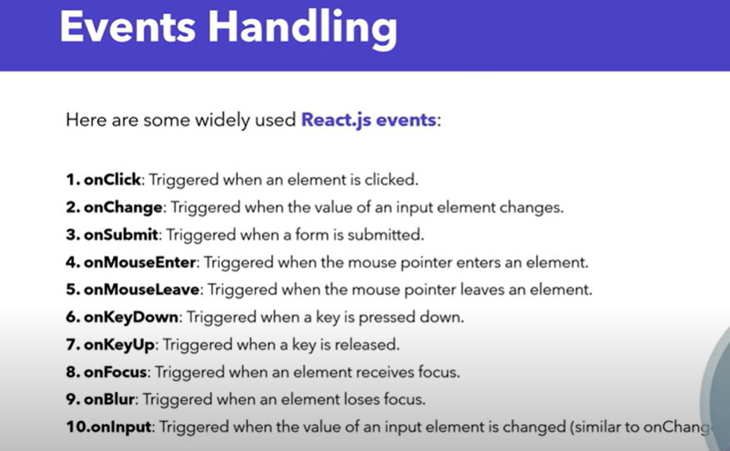

Event naming conversions
onClick, onChange, onSubmit, onMouseEnter
function naming convention
prefix with handle
handleClick, handleChange, handleSubmit
it should be descptive name
handleFormSubmit

inline arrow function

use fat arrow function
const handleClick = (user) => {
console.log(user);
};
<button onclick = {() =>handleClick(‘monika’) }> butotn </button>

Event Propagation in React : Capturing, Bubbling, and Practical Implementation
Event propagation
Event propagation refers to the process of how events propagate or travel through
the dom (document object model) hierarchy.

Jab bhi koi event fire krte hai to , wo jo dom hai hamare dom tree me kaise travel krta hai.
in javascript there are two phases of event propagation
capturing phase
bubling phase
Target phase
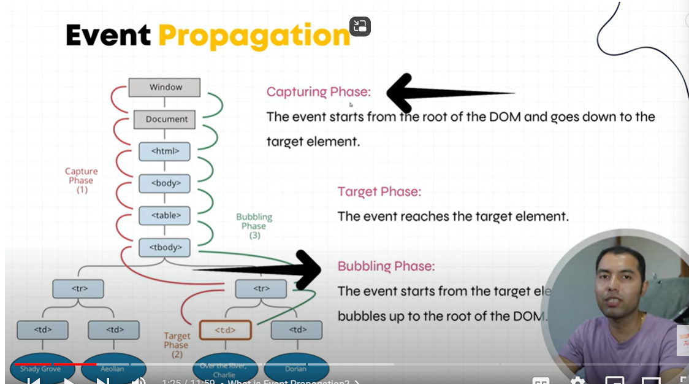

Stop propagation method() : event ko trigger hone me rokne ke liye

onclickCapture – capturing
https://youtu.be/N8RWnqXtSYQ?list=PLwGdqUZWnOp1Rab71vx2zMF6qpwGDB2Z1

capturing – top to bottom event trigger hoge , to perform onclickCapture – capturing

bubbling – bottom to top event trigger hoga

stop propagation – e.stppropagation() ;
event ko trigger hone me rokne ke liye
example
<div> grandparent
<div> parent
<button>child</button>
</div>
</div>

React States: What is useState Hook & Why we need it in React
const [counter, setCounter] = useState(0);

// Function is called everytime increment button is clicked
const handleClick1 = () => {
// Counter state is incremented
setCounter(counter + 1);
};

// Function is called everytime decrement button is clicked
const handleClick2 = () => {
// Counter state is decremented
setCounter(counter - 1);
};

Why the state value does not reset to its initial value on re-render?
const [counter, setCounter] = useState(0);
Whenever this components will render first time then only counter value set to 0.

React JS State Challenge: Master useState with Objects (object inside array – array of an object)
const [user, setUser] = useState([
{
name: "monika1111",
age: 25
},
{
name: "monika2",
age: 26
},
{
name: "monika3",
age: 27
},
{
name: "monika4",
age: 28
}
]);

Derived State in React.js: Improving State Management and Remove Redundancy & Dependency
Array method
const userCount = user.length;

Reduce method
age ka average yha pe nikal skte hai
using reduce method we can count average here.

Why You Need to Lifting State Up in React
Props – pass data from parent component to child component
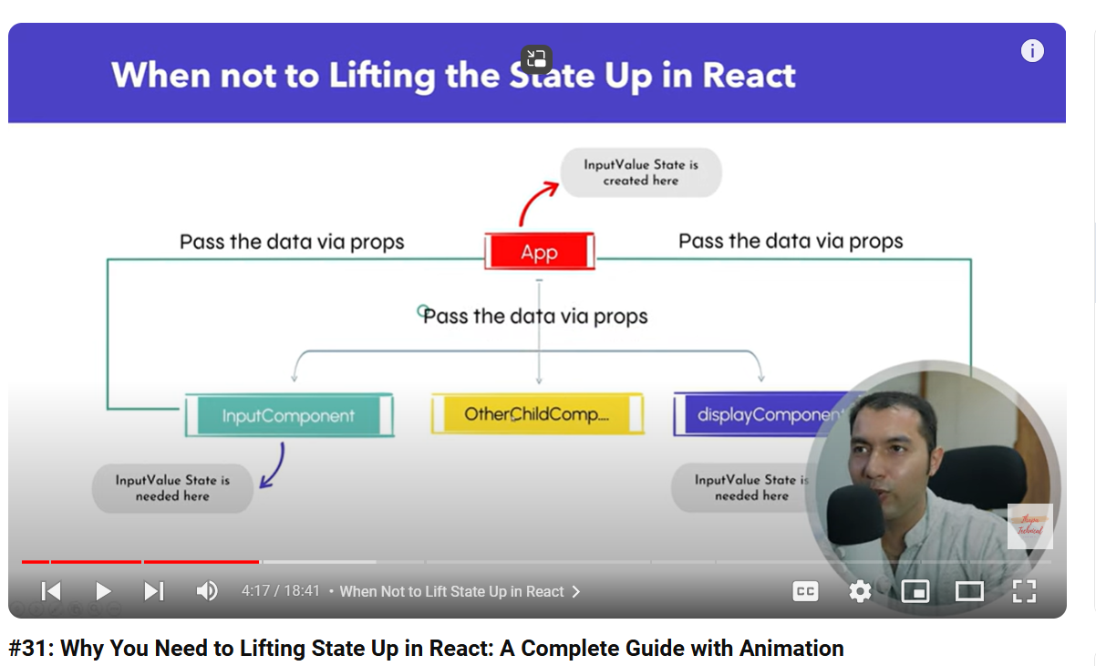

Lifting state up
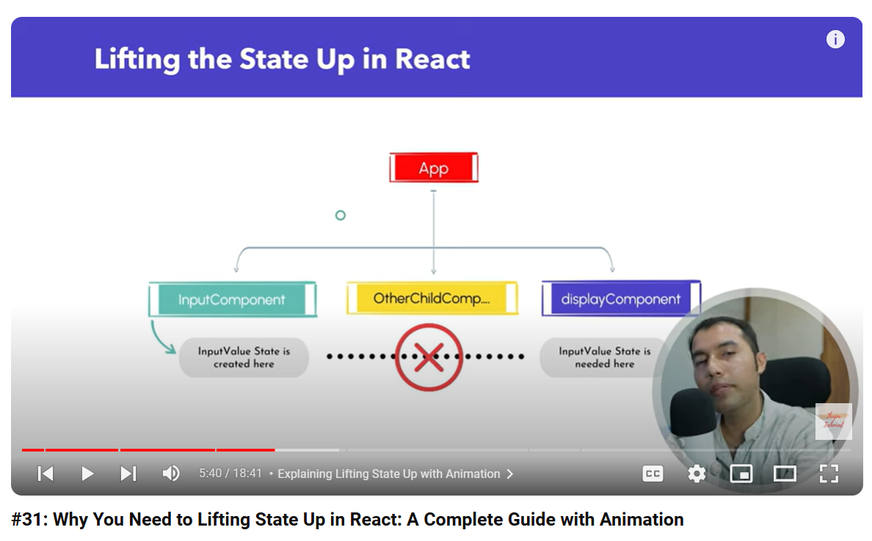

Lifting state up
Ek child se dusre child me data pass krna hai to
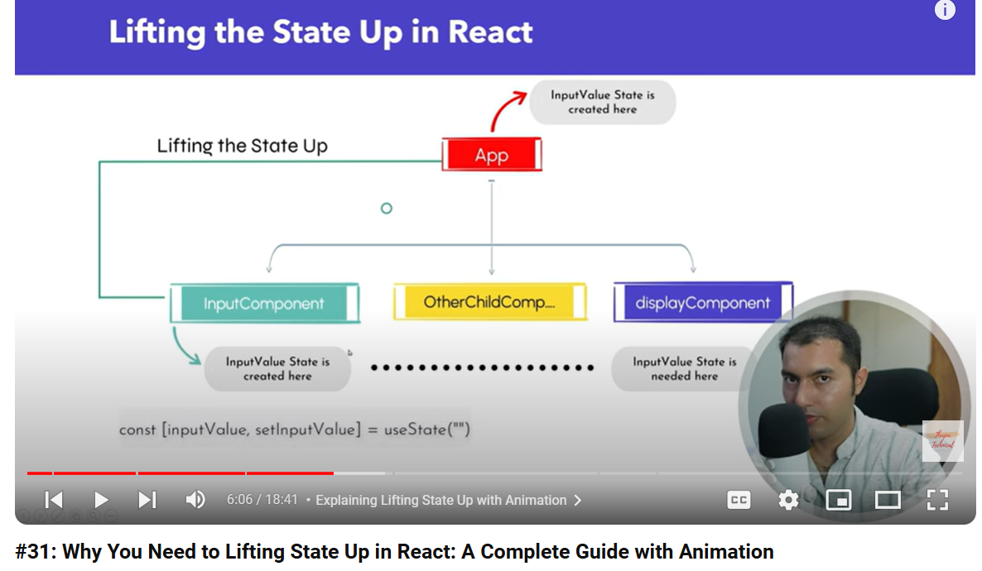
Child ke pass koi state variables thi, common parent me state ko create,
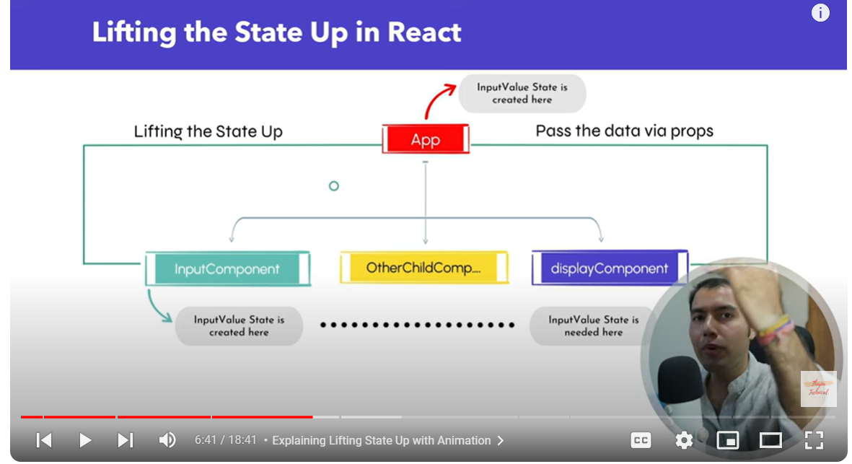

Hum parent ko state create krne ke liye bolte hai,
https://www.geeksforgeeks.org/lifting-state-up-in-reactjs/
https://www.geeksforgeeks.org/explain-the-concept-of-lifting-up-in-react-hooks/
https://youtu.be/GStKM1PQkmI
refer from diff resource

Best Website to Find Icons for Your React App
react-icons - npm (npmjs.com)

Build a Complete Todo App from Scratch
skip

Why Keys Are Important in React JS
Keys to identify element

Short Circuit Evaluation in React JS
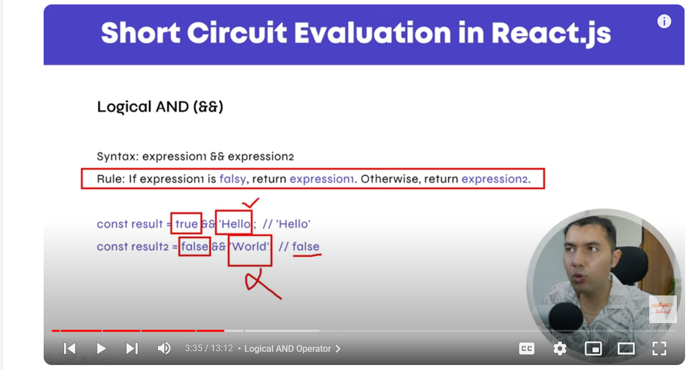
React Hook Rules
Types of hooks
custom hooks
How to Use the useState Hook in React
React useState Hook Challenge

code step by step

https://youtu.be/CbPZFh-CK2s?list=PL8p2I9GklV46469T9uxQ2ORe4AOzsqLb9
86
https://github.com/anil-sidhu/react-17/branches/all

index.js/App.js
npm /yarn

if we want to create a custom command
don’t forget to use
npm run anil
npm run build
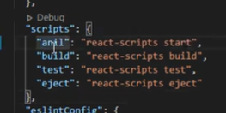

functional Component
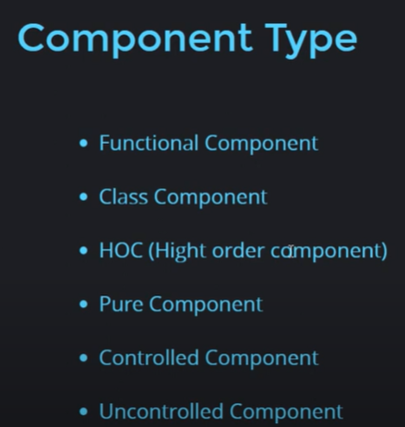

why do we need to use state
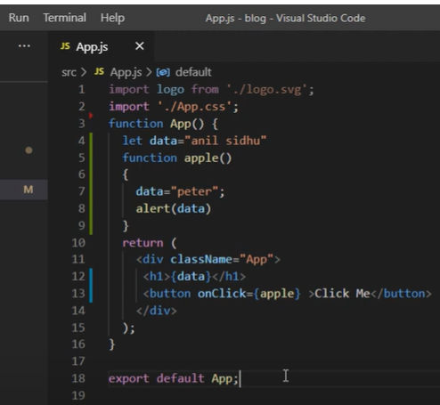
value is not updating
value is not changing
Now we need to use states
note - for variable update react can not understand something updated on my component
It will not going to display the updated value in this return function.
Value can not not update it again in the return block

event and click event
use arrow function to avoid immediate function call

state
using state we can update the value

props
String, number
object, array

get input box value
const [name, setName] = react.useState(“monika”);
<input type = “text” onChange = {(e) => setName(e.target.value)} />
Button click
onChange events – if we type something, get value on real time

Handling html form in react js
how to get the value from the
input fields ,
checkboxes, radio button
function App(){
const[name, setName]= useState(“ “);
const[interest, setInterest]= useState(“ ”);
const[Tnc, setTnc]= useState(false);
function handleSubmit(e){
e.preventDefault();
console.log(name, interest, Tnc)
)
return (
<>
<form onSubmit= {handleSubmit}>
<input type = ‘text’ onChange = {(e) => setName(e.target.value)} placeholder = ‘enter name’/>

<select onChange = {(e) => seInterest(e.target.value)} >
<option>marvel</option>
<option>DC</option>
<select/>

<input type = “checkbox” onChange = {(e) => seTnc(e.target.checked)} /> <span>agree with terms and conditions </span>
</form>
</>
)
}
Condition Rendering
condition ? true : false

form validation
life cycle method
useEffect Hooks
3 phase of lifecycle
mounting
updating
unmounting
mounting phase
mounting phase means that phases when our page gets loaded
when the our component is loading for the first time, that phase is known as mounting phase.
updating phase
Whenever some components changes,
Data gets changes in particular component
Whenever data of the component is change , that component gets re render

unmounting phase
When that component gets killed or when that components gets remove
That particular phase is known as unmounting phase
https://manikandan-b.medium.com/react-functional-component-lifecycle-e8525f8fadea

- useEffect( () => {

})
its will call first time whenever our component load in the browser
it will also call if any state update
- useEffect(() => {
},[]);

It will call only once whenever our component mount in the browser
- useEffect(() => {
}, [data]);
its will call first time whenever our component load in the browser
it will also call on changes on dependency
- clean up function
callback function me function return kra
useEffect(() => {
() => {
}
})

Hooks
useState,
useEffect

fragement
<fragement> </fragement>
<> </>

Passing Events as Props in React | Control Parent Function Using Child Component
https://www.c-sharpcorner.com/article/how-do-you-pass-an-event-handler-to-a-component-in-reactjs/

Example1 – Practice
Using Functional Components with Hooks
If you're using functional components and hooks, the approach is similar. Here's an example using functional components:
Parent Component
import React from 'react';
import ChildComponent from './ChildComponent';

const ParentComponent = () => {
const handleEvent = () => {
console.log('Event handled in the parent component');
};

return (
<div>
<ChildComponent onEvent={handleEvent} />
</div>
);
};

export default ParentComponent;
JavaScript
Child Component
import React from 'react';

const ChildComponent = ({ onEvent }) => {
return (
<button onClick={onEvent}>
Click me
</button>
);
};

export default ChildComponent;
JavaScript
Summary
- Define the event handler in the parent component.
- Pass the event handler as a prop to the child component.
- Use the event handler prop in the child component.
This pattern allows for clean separation of concerns, with the parent component managing the event logic and the child component being responsible for rendering and triggering the event.

Example2 – practice2
Pass Function as Props
We can call this function as many time
function App(){
function getData(){
console.log(“bmn jbjkh”);
}
return(
<User data = {getData} / >
)
}

function User(props){
return(
<>
<button onClick = {props.data}>button</button>
</>
)
}

Example2 - Optinal
export const EventProps = () => {
const handleWelcomeUser = (user) => {
alert(`${user}`);
};
return (
<>
<h1>props</h1>
<WelcomeUser onClick={() => handleWelcomeUser("monika")} />
</>
);
};
const WelcomeUser = (props) => {
const { onClick } = props;
return (
<>
<button onClick={onClick}>sqwsxedes</button>
</>
);
};
export default WelcomeUser;

important topics
send data from child to parent component
Lifting state up
the data which we send from child to parent component can be props, state , constant ,
Anything can be send child to parent .

Make a function inside the parent component
and call it from the child
from the child we just pass some parameter with the data.
and that data will be can be get in the parent component.

parent component
App.js
import {User} from ‘./User’
function App() {
function getName(name){
alert(name);
}
return (
<>
<User getData = {getName} />
</>
)
}
export default App;
child component
User.js
function User(props){
const name = “anil sidhu”;
return (
<>
<button onClick = {() => props.getData(name)}>click me</button>
</>
)
}
export default User;

yoshita jain , lifting state up
Import Child from ‘./Child’
function App() {
function getData(data) {
console.log(data);
}

return (
<>
<Child getData = {getData} />
</>
)
};
export default App;

Child component
function Child(props) {
const[name, setName] = useState();

function handleSubmit(e) {
e.preventDefault();
props.getData(name);
};
return (
<>
<form onSubmit = {handleSubmit}>
<input type = ‘text’ value = {name} onChange = {(e) =>setName(e.target.value)}/>
<button>Submit </button>
</form>

</>
)
}

Output – can see file name app.js
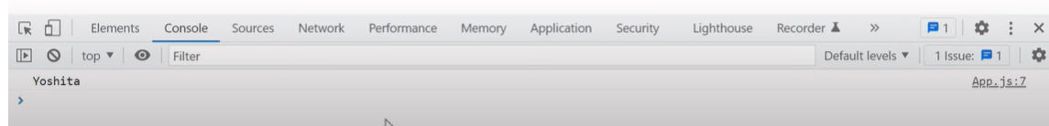

Pure Component
Pure component – Class component
Functional component – React.memo()
Improve project and application performance
Suppose we have a state name, on a button click we are updating the state with the same name
previously state name is like name and again after just updating the state the name is again anil
By default the component will re render the component again every time whenever you will just update an state.
It is dose not match that previous state value and updated state value is same or not.
that’s why if the name is same
Component will re render (update ) again and again , it will just reduce our performance.
pure component it will check that previous state value and updated state value
Updating the state again name is same
components re render again whenever we changes an state
it dose not match that previous state value
and updated state value is same or not that’s why the name is same then it will stop re rendering
Ie the value are different then it will basically re render our component
it will just stop our unwanted re rendering and improve your performance .
example – pure component
class App extends React.PureComponent
now it will only re render our component whenever value is actually updated
We can use pure component with the state as well as with the props.

Class Components:
Extend React.PureComponent instead of React.Component.
JavaScript
import React, { PureComponent } from 'react';
class MyPureComponent extends PureComponent {
render() {
return (
<div>
{/* Component content */}
</div>
);
}
}

React.memo()
When to Use
✅ Use React.memo for functional components when:
- Component renders with the same props frequently.
Functional Components: Wrap the functional component with React.memo().
import React from 'react';
const MyPureFunctionalComponent = React.memo(({ prop1, prop2 }) => {
return (
<div>
{/* Component content */}
</div>
);
});

Later - Usememo
Note – for Usememo we can take example from the hooks documentation
Example without using memo
function app(){

const [count, setCount] = useState(0);
const [item, setItem] = useState(5);

function multiCount(){
console.warn(‘multicount’);
return count*2;
}
return(
<>
<h1> { multiCount } </h1>
<p>{item} </p>
<button onClick = {() => setCount(count+1}>update count </button>
<button onClick = {() => setItem(item+1}>update item</button>
</>
)
}
export default app;
If we click on update count button , multicount is calling which is good
Whenever I click on update it is again calling , it should be not call, according to the performance
But it will be call because of component is re render again and again
So how we can stop it

To resolve this use usememo

Example – using usememo hook
function app(){
const [count, setCount] = useState(0);
const [item, setItem] = useState(5);

const multiMemo = useMemo(function multiCount() => {
console.warn(‘multicount’);
return count*2;
}, [count]);
return(
<>
<h1> { multiMemo } </h1>
<p>{item} </p>
<button onClick = {() => setCount(count+1}>update count </button>
<button onClick = {() => setItem(item+1}>update item</button>
</>
)
}
export default app;

useCallback
remaining

useRef
Using this we can modify dom directly
And in react js if we modify dom directly application speed can be low
React js basically play with the virtual dom , with that way if we modify the dom it will impact our application performance ,
We should avoid this as much as we can do …

Control and update dom of our application
If we have input element and we just want to change color or any kind of style
Using functional component we can do that

Example – if we want to focus in the input fields
import React, { useRef } from "react";
function App() {
const inputRef = React.useRef(null);

function controlInput() {
inputRef.current.value = "abc";
inputRef.current.style.display = "none";
inputRef.current.focus();
}

return (
<>
<input type="text" ref={inputRef} />
<button onClick={controlInput}>Control Input</button>
</>
);
}

export default App;

Forward Ref
code step by step react js
Branches · anil-sidhu/react-17 · GitHub
forward ref is basically – advanced version of ref in react js library
Ref we can use in the same component

Lets say I just want to modified a input box on a behalf of a button
But my input box inside another component
and
button is inside the other component
and how we can interact both of them and how we can just modify the
input box on a click of button
then we will basically use a forward ref

forward ref is just like a we are forwarding a message
in this case we just forward our ref
and forward references

example
App.js
Import User from ‘./user’;
function App(){
const inputRef = React.useRef(null);

function updateInput() {
inputRef.current.value = ‘1000’
};

return (
<>
<h1>forward ref in react js </h1>
<User ref= {inputRef}/>
<button onClick = {updateInput}>update input box </button>
</>
)
};

User.js
Import React, {forwrdRef} from ‘react’;
function User(props, ref) {
return (
<input type = “text” ref = {ref} />
)
};
export default forwardRef(User);

Controlled Component
Component can be handled by two ways one is controlled and other is uncontrolled

Inside our component we have some input fields
It might be only one input field or might be more than one input fields.

When we will handle this input fields with the help of react state , then we called controlled component.

When we handle directly with the dom then we called uncontrolled component
Example of uncontrolled component its like handling a input with the ref
In a jquery we can just put a id to any input field and gets its value

Similiarly we can get a input box value
In the js with the help of getelementbyid

These are three uncontrolled component

Controlled component
Simple component – handled by the react js state
Example – controlled component

function App(){
const [val, setVal] = react.useState(‘ ‘);
const [item, setItem] = react.useState(‘ ‘);

return (
<input type = ‘text’ value = {val} onChange = {(e) =>setVal(e.target.value)} />
<input type = ‘text’ value = {item} onChange = {(e) =>setItem(e.target.value)} />
)
}
Export default App;

UnControlled Component
component which has some input field and not handled by react state
they are handled by dom and react ref.

so these are the uncontrolled component

handle the component with js
and ref

example –
import react from ‘react’
function App(){
let nameRef = useRef(null);
let passwordRef = useRef(null);

function submitForm(e) {
e.preventDefault();
console.log(nameRef.current.value);
console.log(passwordRef.current.value);
}
return(
<form onSubmit = {submitForm}>
<input type = ‘text’ ref = {nameRef} />
<input type = ‘text’ ref = {passwordRef} />
<button>submit</button>
</form>
)
}
output
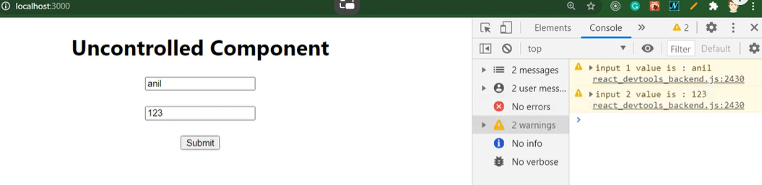

or we can also use javascript code to get the value
Example
import react from ‘react’
function App(){
let nameRef = useRef(null);
let passwordRef = useRef(null);

function submitForm(e) {
e.preventDefault();
console.log(nameRef.current.value);
console.log(passwordRef.current.value);
let email = document.getelementbyid(‘email’).value;
console.log(email);
}
return(
<form onSubmit = {submitForm}>
<input type = ‘text’ ref = {nameRef} />
<input type = ‘text’ ref = {passwordRef} />
<input id = “email” type = ‘text’ />
<button>submit</button>
</form>
)
}

Higher Order Component
a component that take a other component as an input and produce a output as an component also.

Just take a input as an component and output also for this component will be a
component.

Example -
import react from ‘react’;
function App(){
return (
<h1>HOC</>
<Counter />
)
}
function Counter(){
const [count, setCount] = useState(0);
return(
<button onClick = {() =>setCount(count+1)}>update</button>
)
}

export default App;

requirement – this above example is simple one
suppose we have lots of counter on a different different pages same pages an all but every counter might have some additional feature like some extra style , some extra text kind of things .
we can do two things , we can make some conditions here
function Counter(){
const [count, setCount] = useState(0);
return(
<button onClick = {() =>setCount(count+1)}>update</button>
)
}
But what, if we do not know how much conditions we have to apply
then what we can do, we can make a one more component
and that component will be wrapper on a counter. And this is a higher order component.
example -
import react from ‘react’;
function App(){
return (
<h1>HOC</>
<HOCRed cmp = {Counter} />
<HOCGreen cmp = {Counter} />

)
}
function HOCRed(props){
return <h1 style = {{background-color: ‘red’}}> red <props.cmp /> </h1>
}
function HOCGreen(props){
return <h1 style = {{background-color: ‘green’}}> red <props.cmp /> </h1>
}

function Counter(){
const [count, setCount] = useState(0);
return(
<button onClick = {() =>setCount(count+1)}>update</button>
)
}
export default App;
output
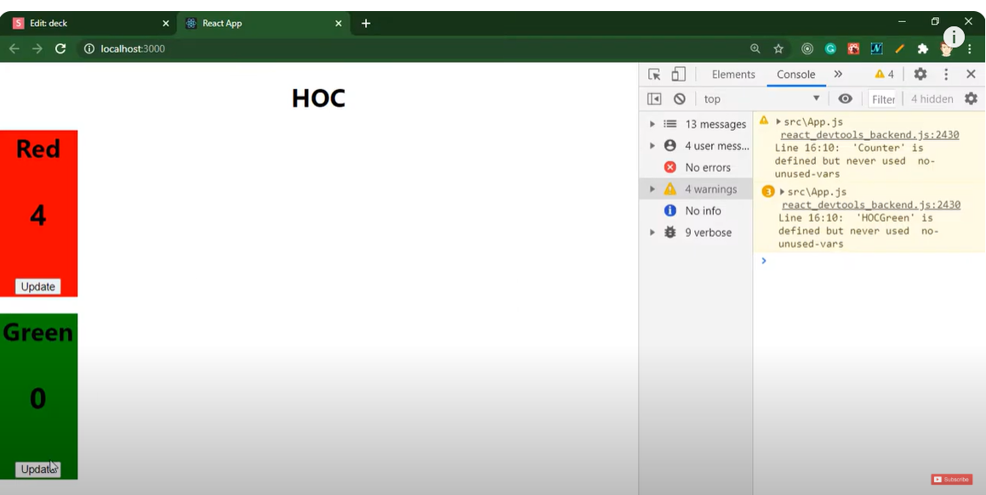

Higher Order Components from other tutorials - refer this one
a function which takes another component as a parameter and returns a new component.
https://youtu.be/CD7rN9hoo34

Example
ClickCounter.js
Import React from ‘react’;
const ClickCounter = () => {

const [count, setCount] = useState(0);

const increamentCount = () => {
setCount(count => count+1);
}

return (
<h1>{count}</h1>
<button onClick = {increamentCounter}>click counter</button>
)
}
Export default ClickCounter;

MouseOverCounter.js
Import React from ‘react’;
const MouseOverCounter = () => {
const [count, setCount] = useState(0);

const increamentCount = () => {
setCount(count => count+1);
}

return (
<h1>{count}</h1>
<button onMouseOver = {increamentCount}>Mouse Over Counter </button>
)
}
Export default MouseOverCounter;

App.js
import react from ‘react’;
const App () => {
return (
<ClickCounter></ClickCounter>
<MouseOverCounter></MouseOverCounter>
)
}
export default App;

output
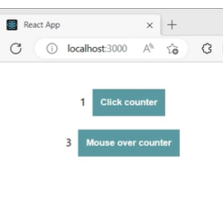
button is different , other than that everything is same
repeatation of the code ,
reaptation of the code in a multiple component which is not a good practice,
in order to avoid that , react has provided a concept called higher order component

hoc is nothing but a function which will do some logic on a some component
and return a new component with the enhanced features.

withCounter.js
const withCounter = (OriginalComponent) => {
// perform some logic on original component
const NewComponent = () => {

}
return NewComponent;
}
export default withCounter;

we have a function that accept some component as input.
Component name – original component
Perform some logic and return a new component.

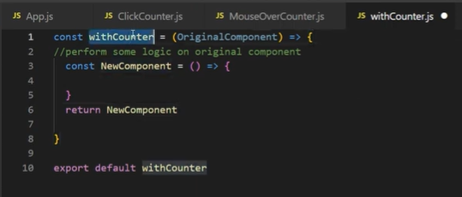

withCounter.js
const withCounter = (OriginalComponent) => {
// perform some logic on original component

const NewComponent = () => {

const [count, setCount] = useState(0);
const increamentCount = () => {
setCount(count => count+1);
}
return (
<div>{count}
<OriginalComponent increament = { increamentCount } />
</div>
)
}

return NewComponent;
}
export default withCounter;

We are trying to move redundant code , generalized location
This new component should be able to display whatever original component has.

This original component should have access to this increament count method
Using props we can pass data from one component to other component

Now higher order component is ready
How to use this higher order component in ClickCounter and MouseOverCounter
Our goal is remove to redundant code
We want this increamentCount to be available here but it should come from higherOrderComponent

In order to use higherordercomponent

ClickCounter.js
Import React from ‘react’;
Import withCounter from ‘./withOrder’;
const ClickCounter = (props) => {
return (
<h1>{count}</h1>
<button onClick = {props.increament}>click counter</button>
)
}
export default withCounter(ClickCounter);

we have function in withCounter component and we are calling that function here
and parameter to that function is a component , in our case it is clickCounter component

withCounter with a ClickCounter as a parameter will go here it will
lets use the property of new component
because in withcounter component increament is passed as props

now accesing increament method using props

same repeat for MouseOverCounter

example
MouseOverCounter.js
Import React from ‘react’;
Import withCounter from ‘./withCounter’
const MouseOverCounter = (props) => {
return (
<h1>{count}</h1>
<button onMouseOver = {props.increament}>Mouse Over Counter </button>
)
}
Export default withCounter(MouseOverCounter);

Lazy loading / code splitting
Code step by
https://youtu.be/ZOpf_ueF65A?list=PL8p2I9GklV44oDSE3j-E-OkvxFkz5a1d8

React me jab hamari application kafi heavy ho jate hai , to wo loading hone me kuch time leti hai
jo hamara code jaldi ready ho rha hai, usko hum jaldi load krwa denge
jo bad me load ho rha hai , wha pe usko hum bad me load krwa denge

Jo hamara code jaldi load krna hai usko hum jaldi load krwa skte hai jo hamara complex code hai
this is also code splitting

ek hi component hai uske undar bahut sara code likha hua hai
kuch uske undar jaldi load hone wale hai , kuch bad me
jo bad me late me load hone wala hai , usko hum alag component me bhi rkh skte hai

example
App.js
Import react from ‘react’;
function App(){
return (
<h1>lazy loading</h1>
)
}
Export default App;

Home.js
function Home(){
return (
<div> home component </div>
)
}
export default App;

About.js
function About(){
return (
<div> Home Component </div>
)
}
export default About;

component load hone me time lg rha hai , ab esko kaise overcome krenge
App.js
Import React, {Suspense, Lazy} from ‘react’;
const Home = Lazy(() => import (‘./Home’));
function App(){
return (
<div>
<h1>lazy loading</h1>
<Suspense fallback = {<div>please wait……</div>}>
<Home />
</Suspense>
</div>
)
}
Export default App;

Output
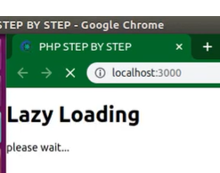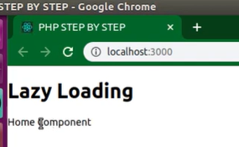

Home and about component together
App.js
Import React, {Suspense, Lazy} from ‘react’;
const Home = Lazy(() => import (‘./Home’));
const About = Lazy(() => import (‘./About’));
function App(){
return (
<div>
<h1>lazy loading</h1>
<Suspense fallback = {<div>please wait……</div>}>
<Home />
<About />
<Suspense>
</div>
)
}
Export default App;
lazy loading
Yoshita jain
https://youtu.be/-L2e1dR1UIE
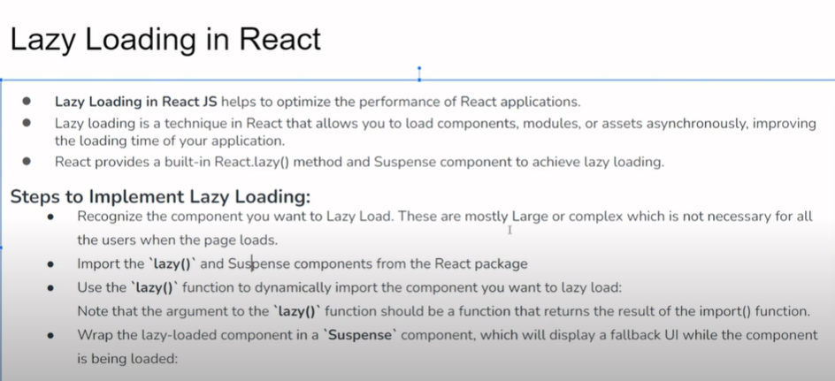

Refer above example from code step by step

Error Boundary in react Js
https://medium.com/@ignatovich.dm/how-to-create-a-functional-error-boundary-in-react-with-some-limitations-a0fd6a598d81

